

**This event is proudly organised by:**

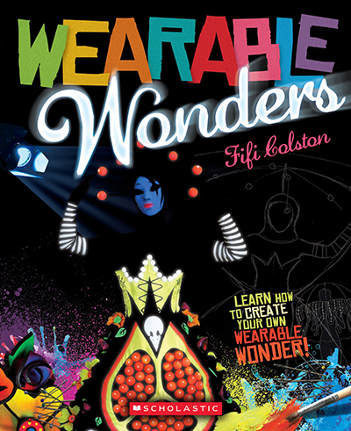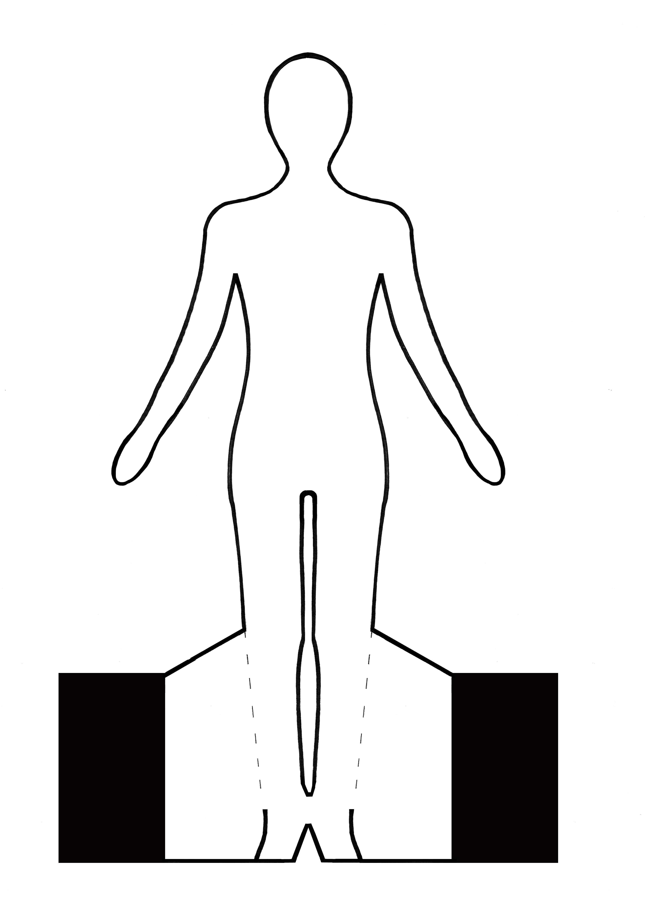

**Wearable Wonders – Craft session**

Join us for a fun session. Get your creative juices flowing and create your very own mini Wearable Wonder model. All ages.

**DATE:** Saturday 17th May 2014

**TIME:** 1pm – 3pm

**PLACE:** Sound and Vision area, Palmerston North City Library



­