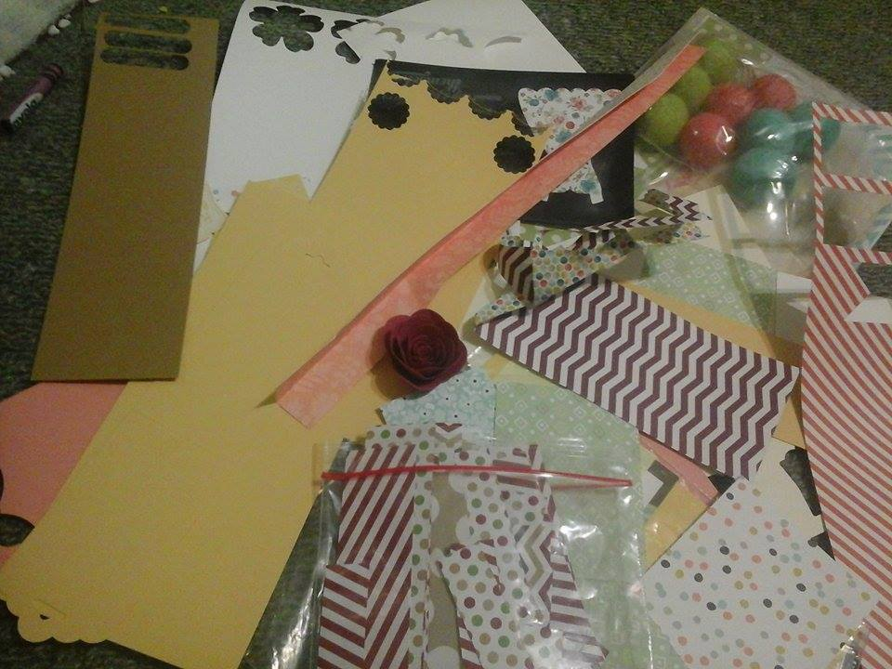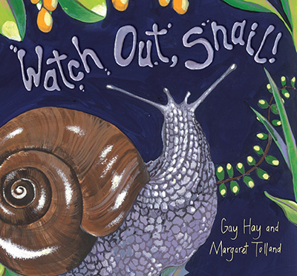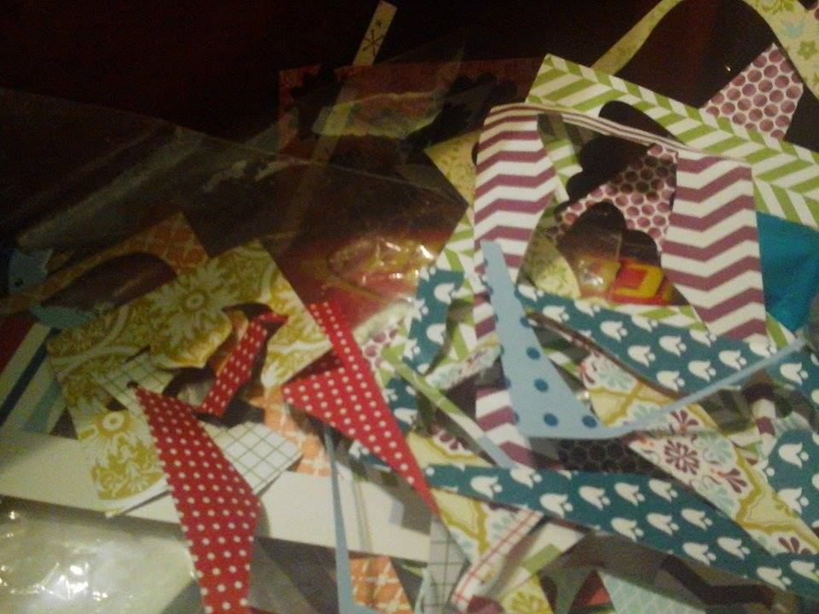

**This event is proudly organised by:**

**In conjunction with**

**Paper Plus Feilding**

**Watch Out Snail – Collage craft session**

Join us for a fun session. Get your creative juices flowing and create your very own snail collage.

All ages.

**DATE:** Wednesday 21st May 2014

**TIME:** 3.30pm – 5pm

**PLACE:** Paper Plus Feilding, Manchester Square.



­