**Photographer: Mike Heydon**



**This event is proudly organised by:**

**In conjunction with**

**Paper Plus**

**Palmerston North**

­

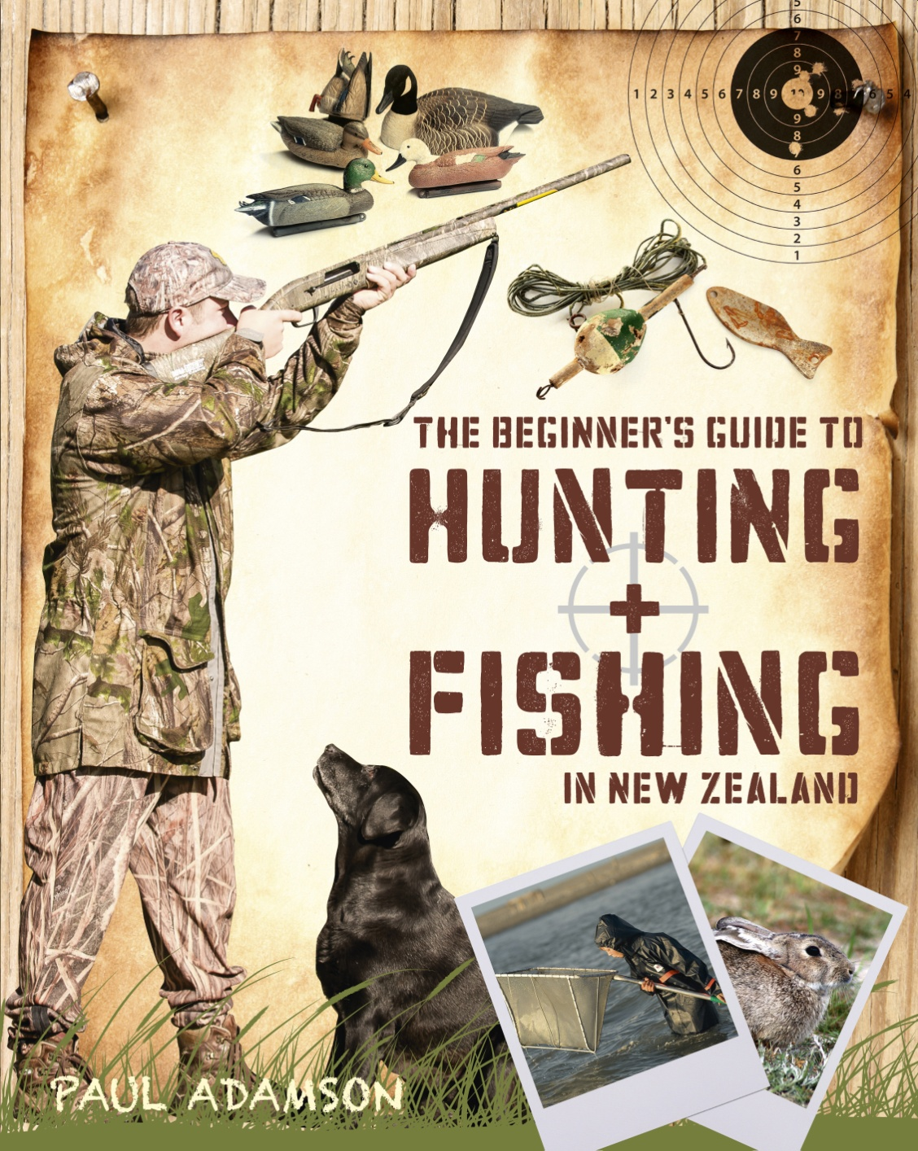

**Paul Adamson – book signing**

Grab the chance to meet Paul Adamson, author of The Beginner’s Guide to Hunting, and get some tips while you get your book autographed!

**DATE:** Tuesday 20th May 2014

**TIME:** 4pm – 5pm

**PLACE:** Paper Plus Palmerston North, 85-88 The Square