

**Photographer: Mike Heydon**

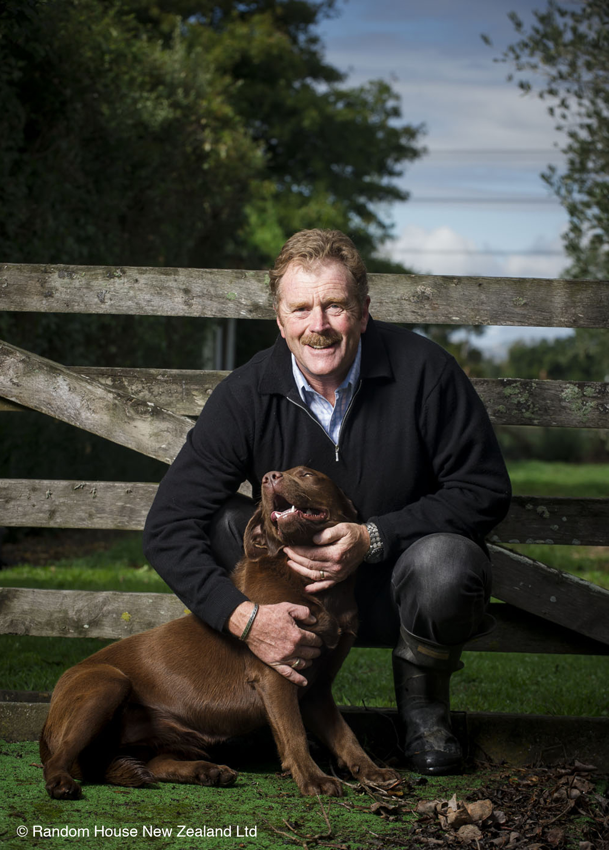

­



**This event is proudly organised by:**

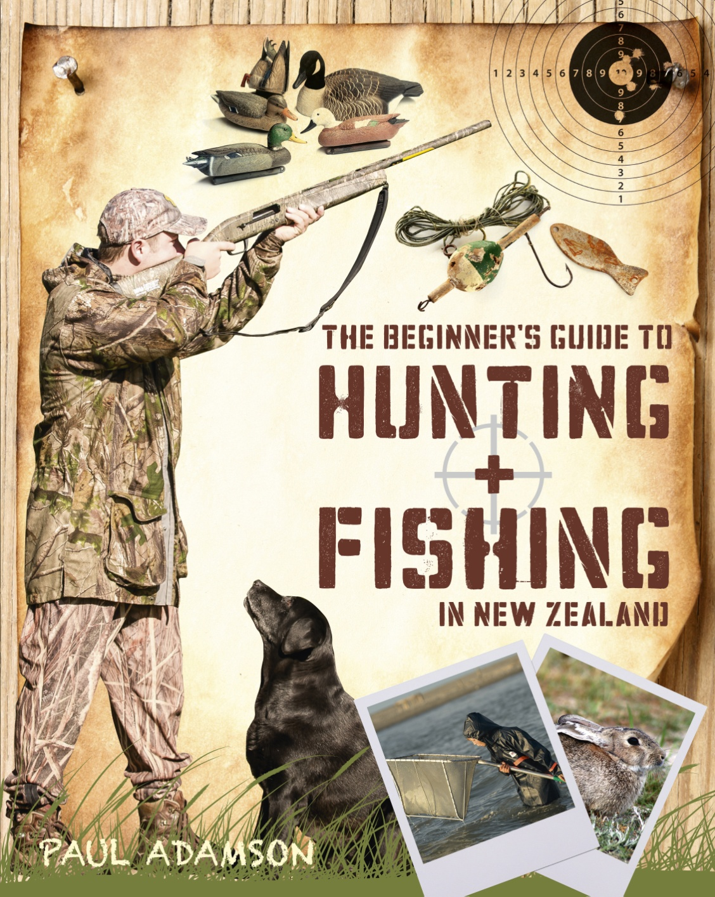

**Boys Big Brekkie**

NZ Post Book Award Finalist, Paul Adamson, joins boys from various schools in the Manawatu and shares his experiences, tips and tricks for hunting and fishing in New Zealand. All participants get to try a variety of 'wild foods' for brekkie, kindly organised and sponsored by Hunting & Fishing Manawatu.

Please register at manawaturealm@gmail.com by 5pm Monday 19th May for catering purposes.

DATE: Tuesday 20th May 2014

TIME: 7am – 8.30am

PLACE: Youth Space, Coleman Mall, Palmerston North.